**Technical Documentation – Executes simple Data Changes**

1. Workflow – Deploys and executes the Oracle Harness to an Environment.

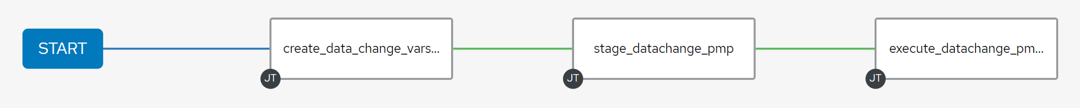

1. Survey – User Supplied Variables

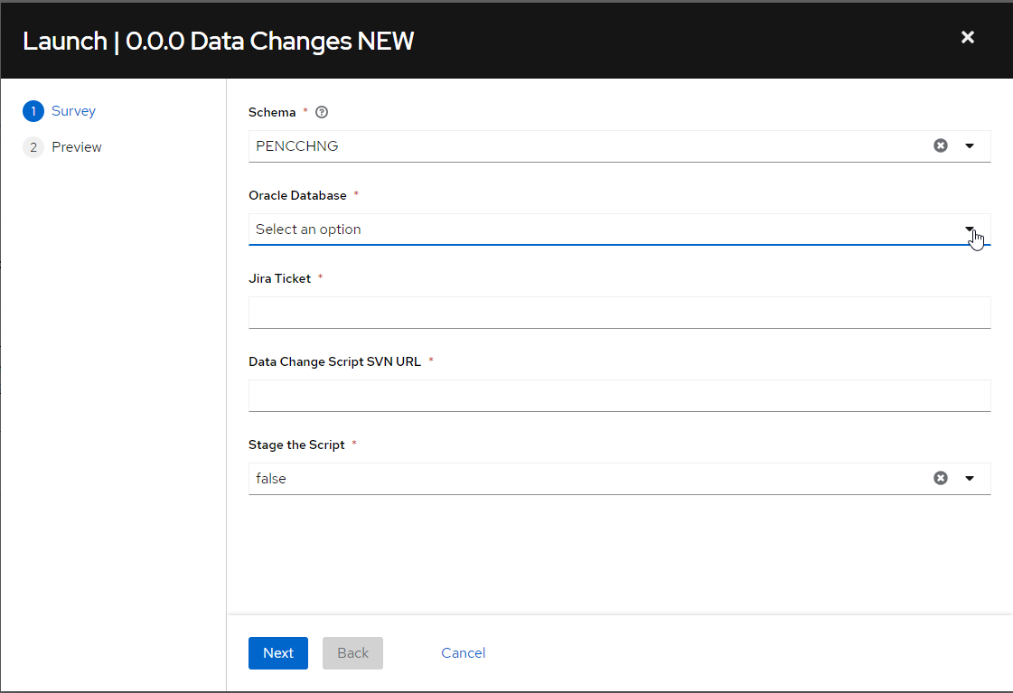

|  |  |  |  |
| --- | --- | --- | --- |
| **Survey Extra Variables** | **Prompt** | **Type** | **Description and Usage** |
| Schema | Schema | Multiple Choice Single Select | The schema to execute the data change as – PENCCHNG typically used for DEVL, DEV3, RDEV, TST1, TST2, TST3, MUAT, IPASP and PENCWEBCHNG used for WEBD, WEBT, WEBM, WEBP. |
| ENV | Oracle Database | Multiple Choice Single Pick | The Environment to Deploy to: DEVL, DEV3, RDEV, TST1, TST2, TST3, MUAT, IPASP, WEBD, WEBT, WEBM, WEBP. Only a single environment can be deployed to per workflow execution |
| JIRATicket | Jira Ticket | Text | The Jira Ticket associated with the Data Change – This is used |
| DataChangeScript | Data Change Script SVN URL | Text | The SVN URL that is obtained from selecting the ‘Copy To Clipboard – FULL DATA’ from the Tortoise SVN REPO Browser |
| STAGE | Stage | Multiple Choice Single Pick | true or false – Exports the sql file if set to true. Typically set to true for environments other than IPASP/WEBP |

EXTRA VARIABLES – at Workflow Level

|  |  |  |
| --- | --- | --- |
| **Extra Variables** | **Value** | **Description and Usage** |
| pmp_url | https://acisbcp.penc.local:7272 | The url to the Password Manager Pro Application – Used to obtain the Oracle Schema Passwords |
| migration_log_url | http://dardanos1bcp.penc.local:7005/ords/devops/test2/log/record2/new/ | The URL for APEX/ORDS that houses the migration_log table. |

1. Jobs Used by the workflow - http://owl.penc.local:18080/svn/deploy_automation/trunk/Ansible_PlayBooks/Harness

| **Job Template** | **Ansible Playbook** | **Credential / host** | **Project** | **Description and Usage** |
| --- | --- | --- | --- | --- |
| create_data_change_vars_v1 | create_datachange_vars_v1.yml | pencmw | Harness | Creates Variables/Artifacts for use within the workflows, based on the User supplied survey results.  Artifacts Defined with examples  StageDir: /codemove_common/dp_automation/DataChanges/OPS-4049  DeploymentLogDir: /codemove_common/dp_automation/DataChanges/OPS-4049  stage_server: diagoras1bcp  tower_hostname: pdevops1bcp.penc.local  date_time: '20220729_2344'  ml_date_time: '2022-07-29-23:44:27'  repo_url: >-  https://owl.penc.local:18080/svn/oracle_ops_source/trunk/OPS_Scripts/ops-4049.sql  script_to_export: ops-4049.sql  script_author: michmaik  new_script_name: ops-4049-4696.sql  spool_file_name: ops-4049-4696_PENCCHNG_MUAT_spool.txt  revision_of_file: '4696'  EnvironmentType: MAINTENANCE |
| stage_datachange_pmp | stage_datachange_pmp.yml | codemove on {{stage_server}} – typically diagoras1bcp  SVN credential:  pencdeploy_svn | Harness | Creates the {{StageDir}}  Exports the {{script_to_export}} to the {{StageDir}}/{{new_script_name}} when {{STAGE}} is true |
| execute_datachange_pmp_new_v1 | execute_datachange_pmp_new_v1.yml | pencmw on {{pdevops1bcp}}  PMP Credential: PMP_ANSIBLE_AUTH_TOKEN | Harness | Reformats the {{new_script_name}} sql file with sqldeveloper sdcli. This is done as a number of datachange scripts are generated with MS Excel which can create sql files with lines longer than the maximum allowed for sqlplus.  Extracts and checks the password for the {{SCHEMA}} from Password Manager PRO.  Moves the spool file (if it already exists) to a name with a timestamp.  Executes the DataChange sql script – creating a spool file.  Updates the migration log table. |